**DAILY ONLINE ACTIVITIES SUMMARY**

|  |  |  |  |  |  |  |  |  |
| --- | --- | --- | --- | --- | --- | --- | --- | --- |
| **Date:** | **14/08/2020** | | | | | **Name:** | **Spoorthy Balaji** | |
| **Sem & Sec** | **6th & B** | | | | | **USN:** | **4al17cs098** | |
| **Online Test Summary** | | | | | | | | |
| **Subject** | | **-** | | | | | | |
| **Max. Marks** | | **-** | | **Score** | | | **-** | |
| **Certification Course Summary** | | | | | | | | |
| **Course** | Introduction to Cybersecurity Tools & Cyber Attacks | | | | | | | |
| **Certificate Provider** | | | **Coursera** | | **Duration** | | | **4Weeks** |
| **Coding Challenges** | | | | | | | | |
| **Problem Statement: Python program to check if a string contains all unique characters** | | | | | | | | |
| **Status: Solved** | | | | | | | | |
| **Uploaded the report in Github** | | | | | **yes** | | | |
| **If yes Repository name** | | | | | <https://github.com/spoorthybalaji/Daily_Status> | | | |
| **Uploaded the report in slack** | | | | | **yes** | | | |

**ONLINE COURSE**

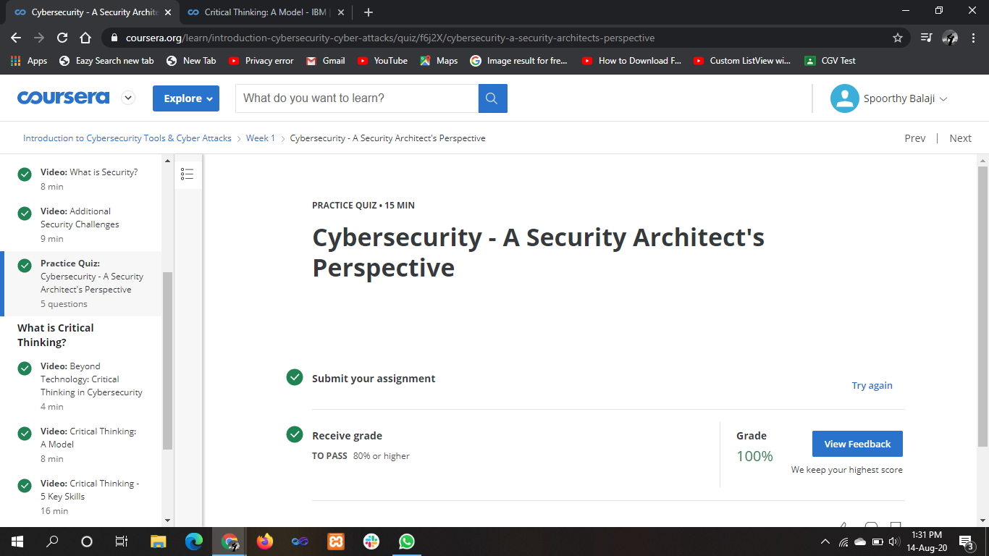

**ONLINE** **CODING**

**Python program to check if a string contains all unique characters**

def isUniqueChars(st):

if len(st) > 256:

return False

char_set = [False] * 128

for i in range(0, len(st)):

val = ord(st[i])

if char_set[val]:

return False

char_set[val] = True

return True

st = "tutorialspoint"

print(isUniqueChars(st))

